***Case Study 1.2: Insulins suitable for FCL*** *Jiri Borek*

*Draft V.1 Sumnmary from:* [*https://www.facebook.com/download/831505605647892/What%20about%20insulin%20in%20FCL%20mode.pdf*](https://www.facebook.com/download/831505605647892/What%20about%20insulin%20in%20FCL%20mode.pdf)

**Method**

iAPS using Dexcome g6/7, Dash, iPhone. autoISF, or which alternative method to ramp up SMBs?

SMB+UAM FCL mode without any bolus or carb input or TT setting by the user. For one full week with a standardized sequence of meals (150 – 300 g carb/d; and no exercise after meals), the FCL performance was established for each of the 4 insulins trialled: Fiasp 100 ui, Apidra 100 ui, Humalog 200 ui, and Lyumjev 200 ui.

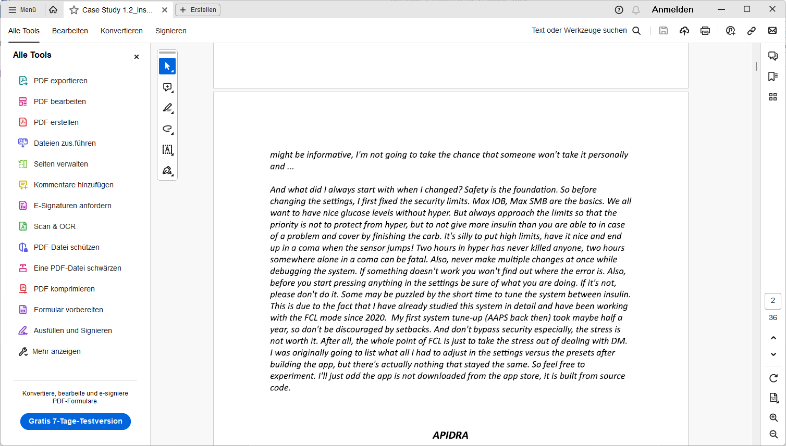

**Apidra**

What surprised me about Apidra was the pretty quick onset. It managed the glycemia quire successfully. >But – maybe due to ist longer DIA – I had to feed (against) hypoglycemia a few times. 38 values under 3.9 mmol in 1 week (2% of all values are below range) is not terrible, but created a bit of discomfort taking away from the intended ease in FCL.

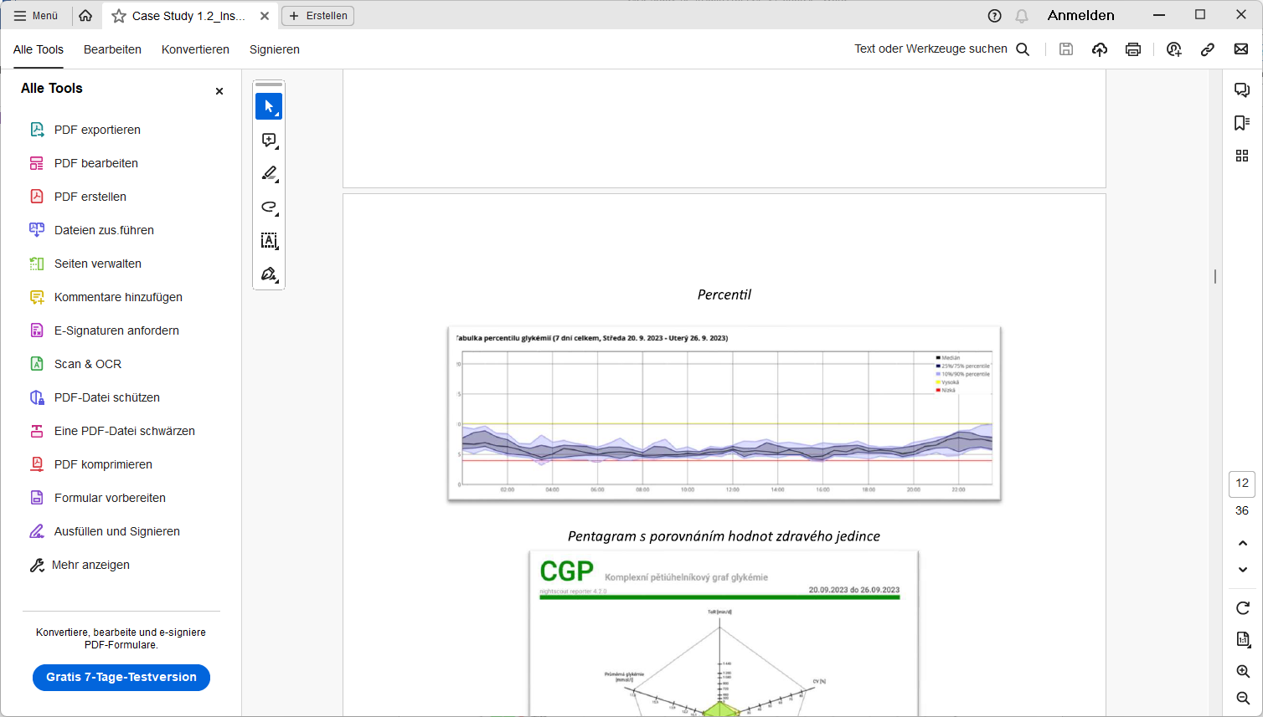

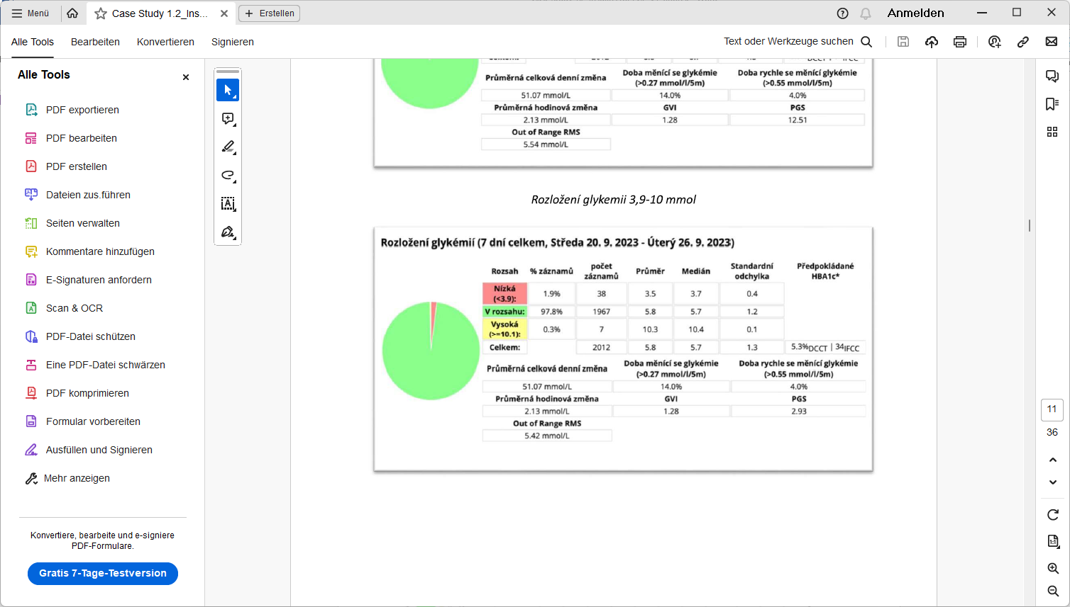

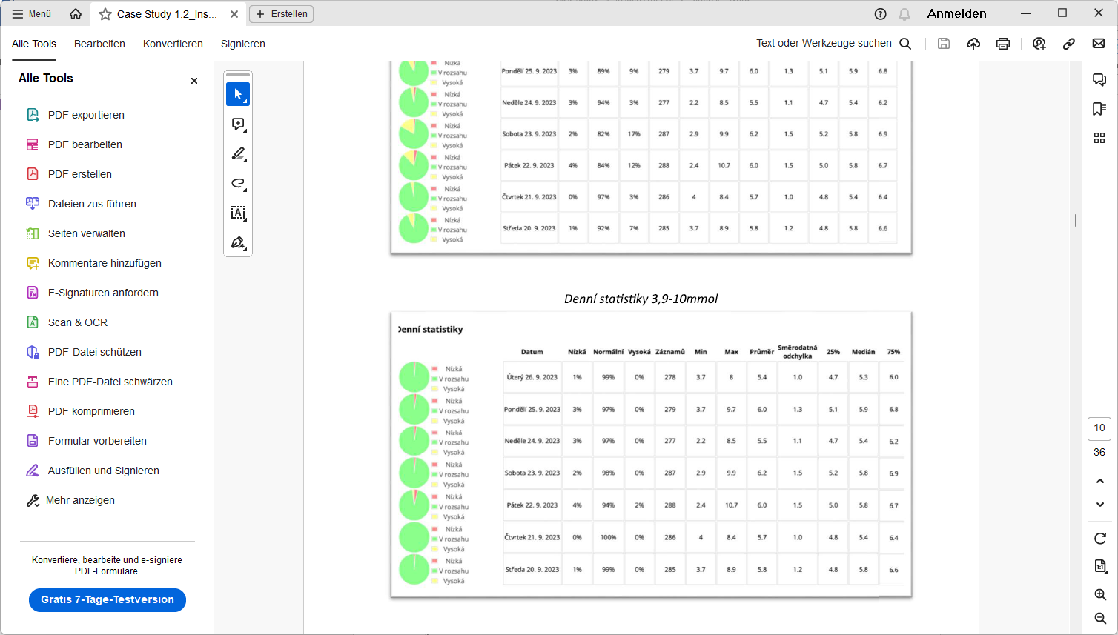

High carb day

Low carb day

**Fiasp**

I observed some problems also many others have reported, like or tendency towards partial occlusions and elevated insulin need with cannula age. In FCL operation (with regular pod changes, and the typical smaller boli occurring in FCL) overall Fiasp worked well and fairly muchg replicated the good resultzs as was reported for Apidra:

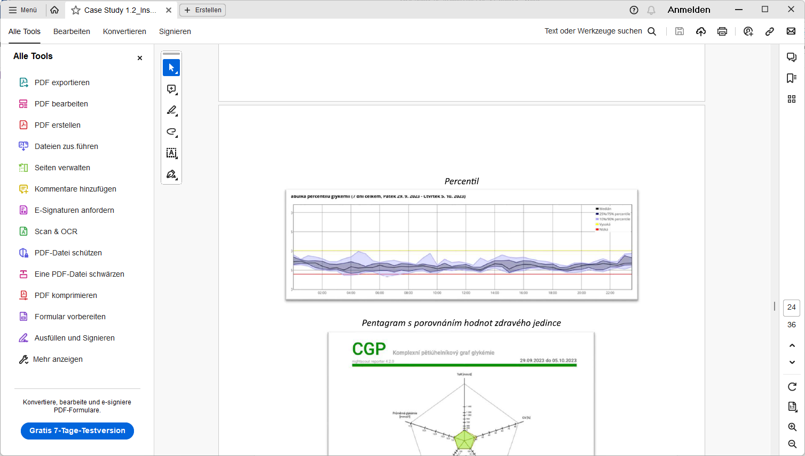

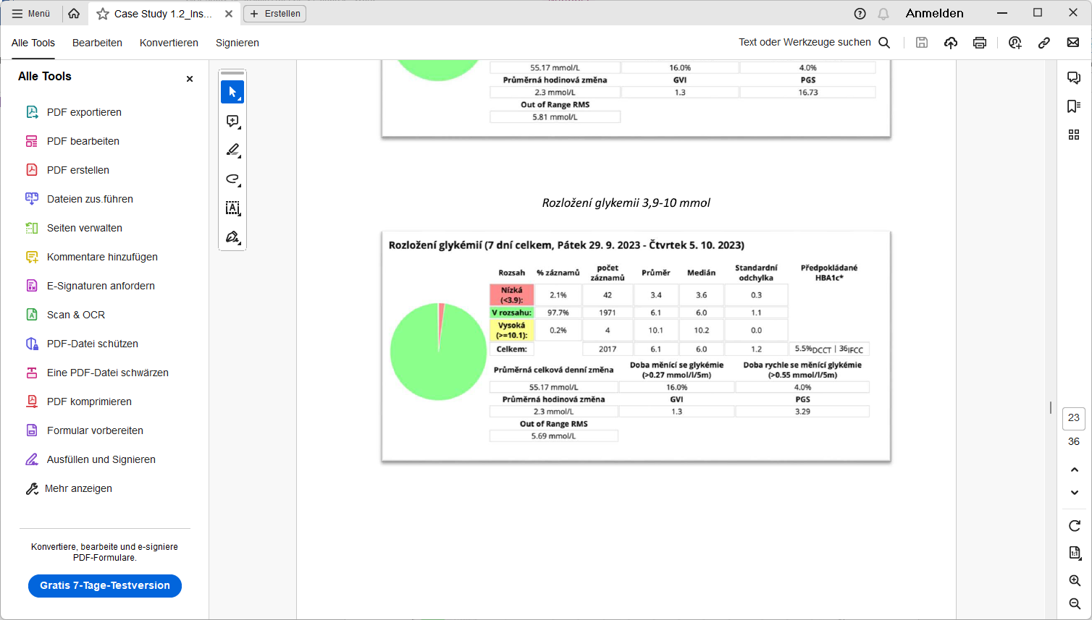

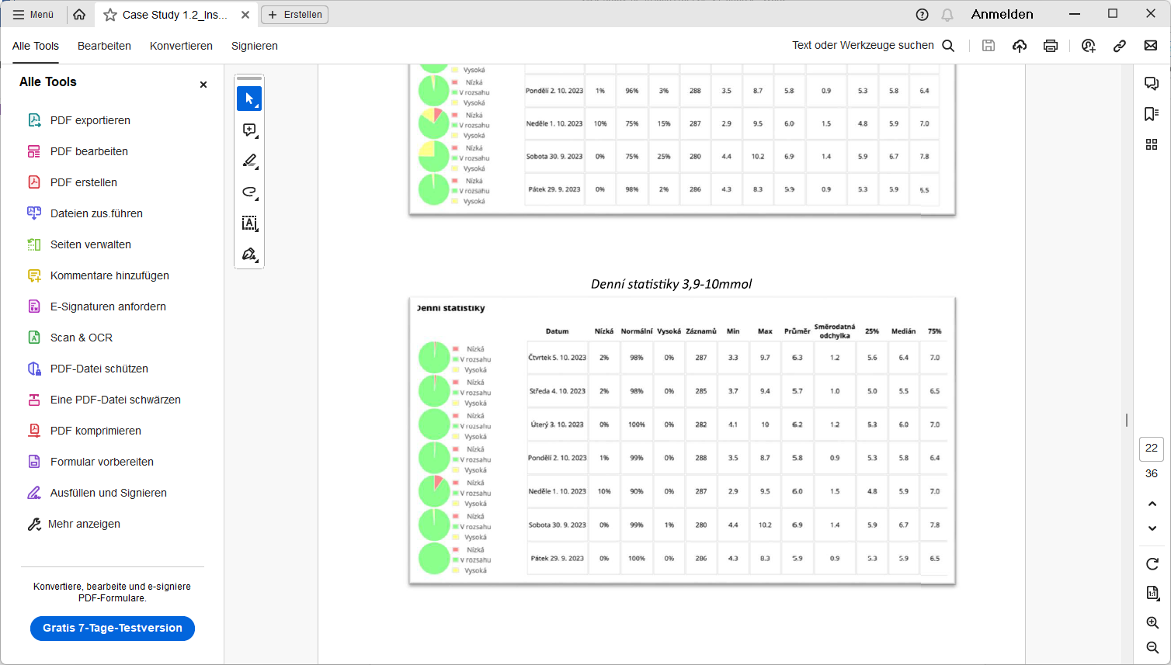

**Humalog**

Of the tested insulins, it was the

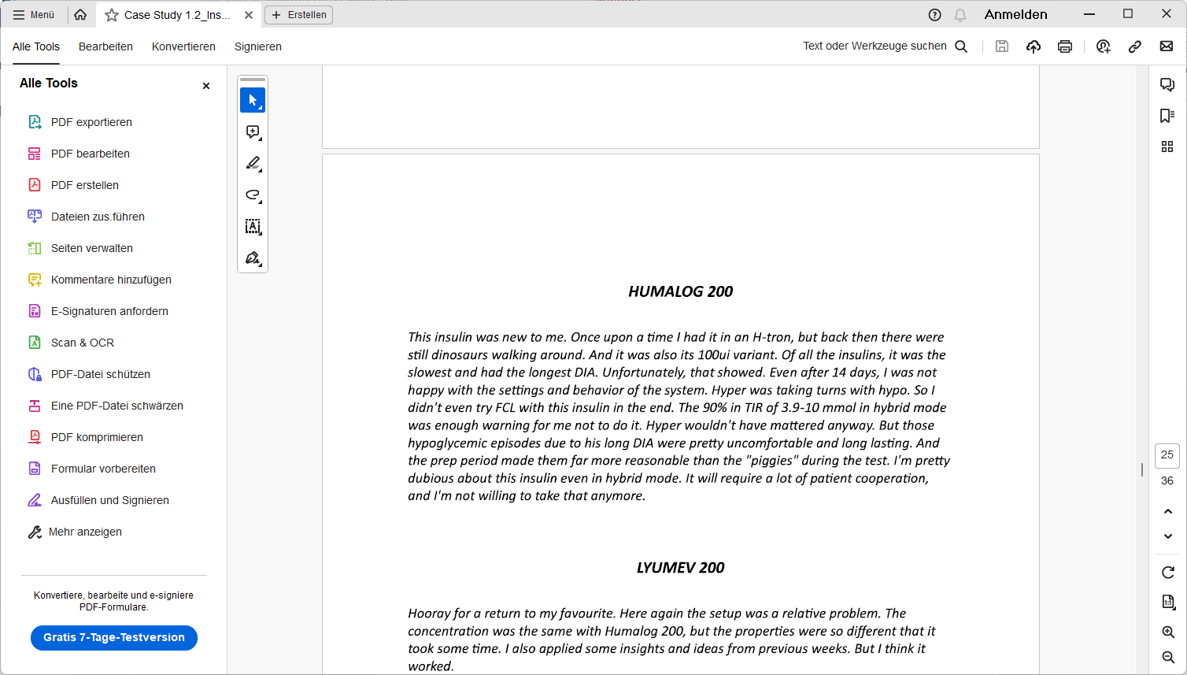

**Lyumjev**

Lyumjev is the insulin with fastest onset and shortest DIA. At the 3.9-10 mmol TIR level, where I has also with Apidra and Fiasp reached ~97%TIR, the difference was less obvious…

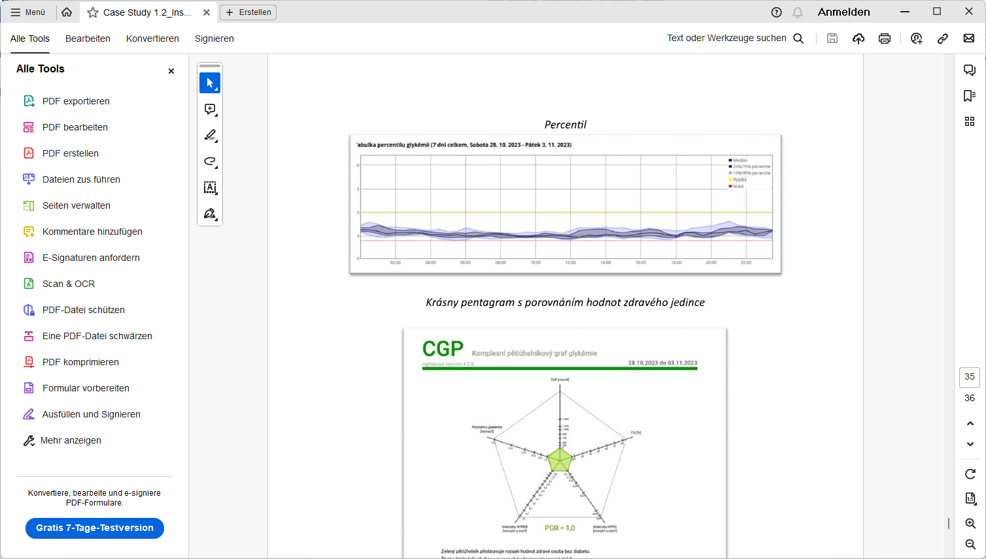

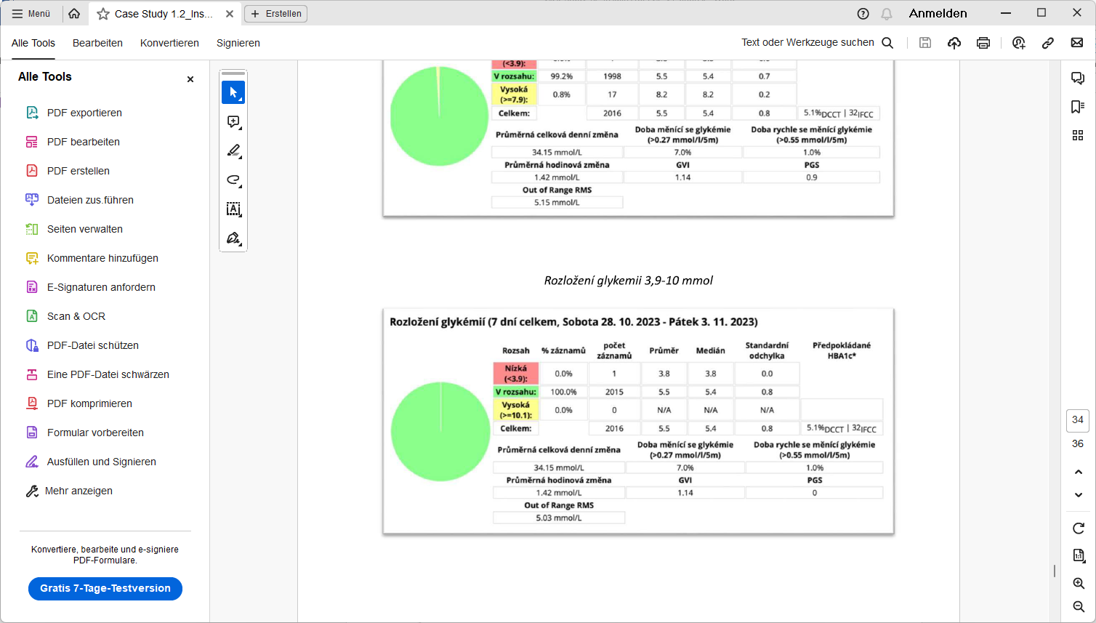

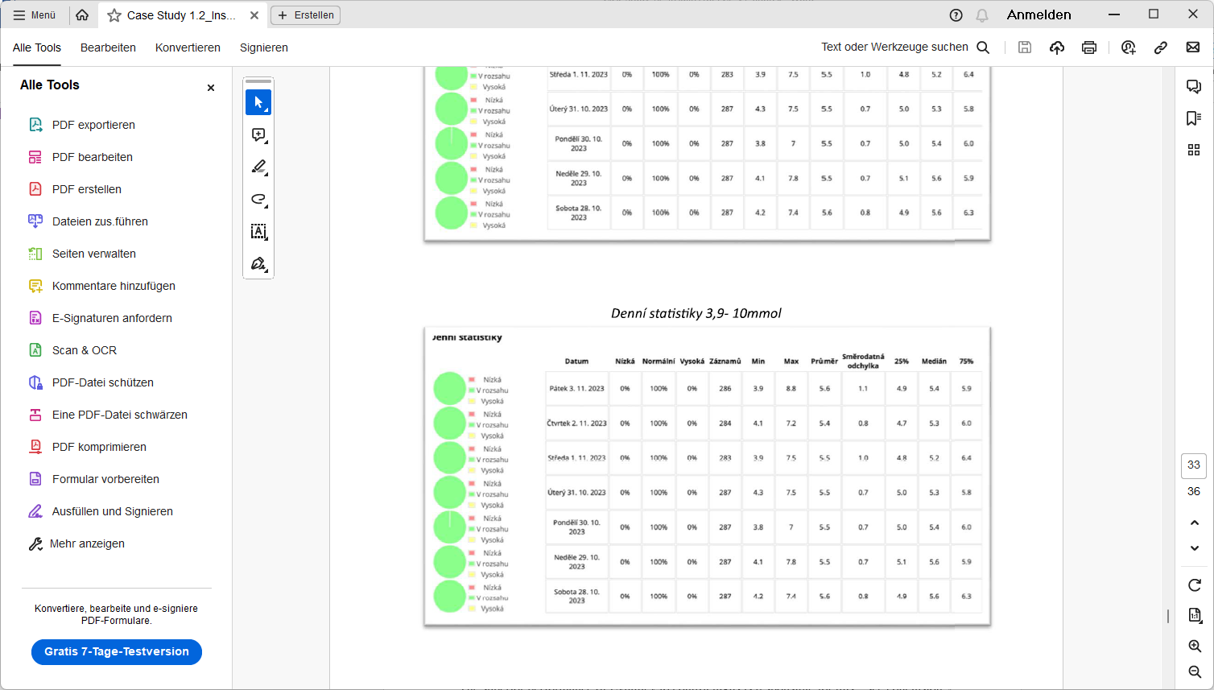

It is very interesting that with Lyumjev I reached the lowest predicted HbA1c (5.1%), despite it coming with a vastly lower incidence of low (0,0% <3.9) values when comparing with Apidra (5.3 % HbA1c @ 1,9% <3.9) and Fiasp (5.5 % HbA1c @ 2,1% <3.9).

The superior performance of Lyumjev to control highs is responsible for this – see conclusion.

**Conclusion**

Lyumjev clearly is the best insulin for my FCL.

* It showed practically no tendency towards hypoglycemia.
* It controlled peaks the best.

This can be best seen when comparing %TIR (3.9 – 7.9 mmol/L)(70-142 mg/dl) between the studied insulins:

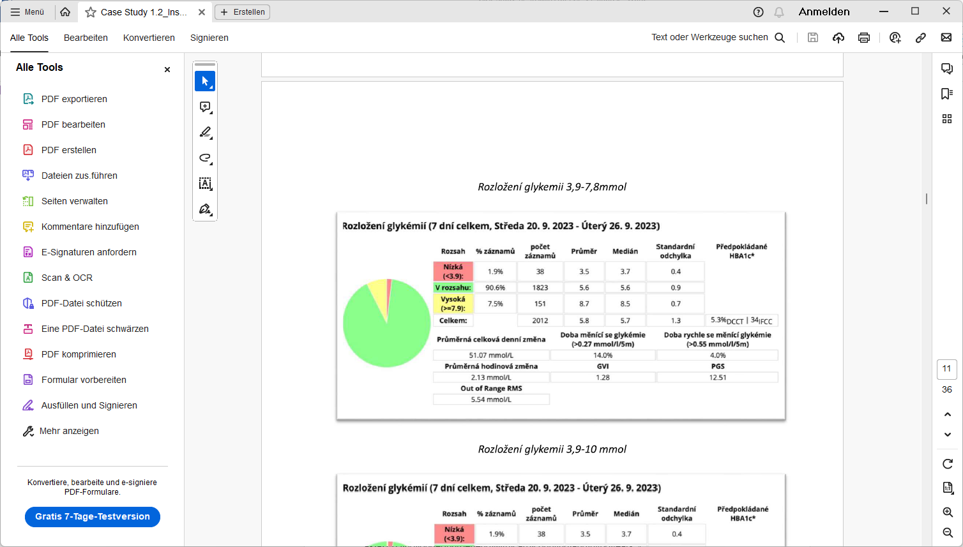 Apidra

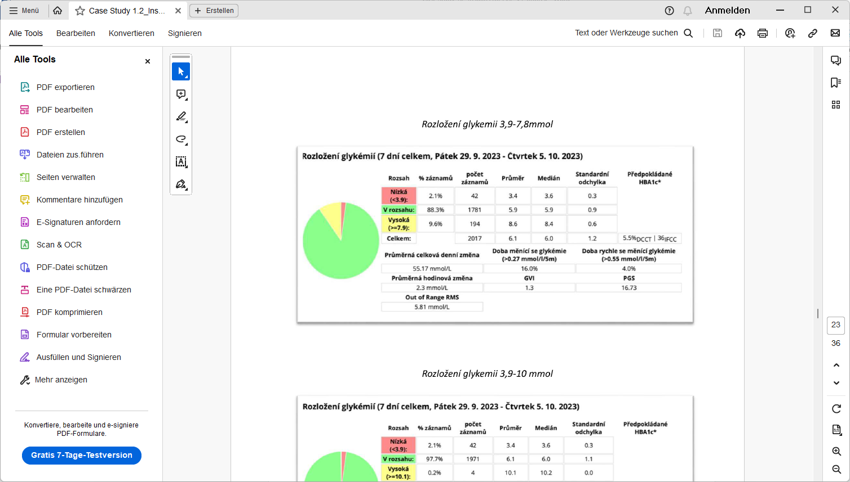Fiasp

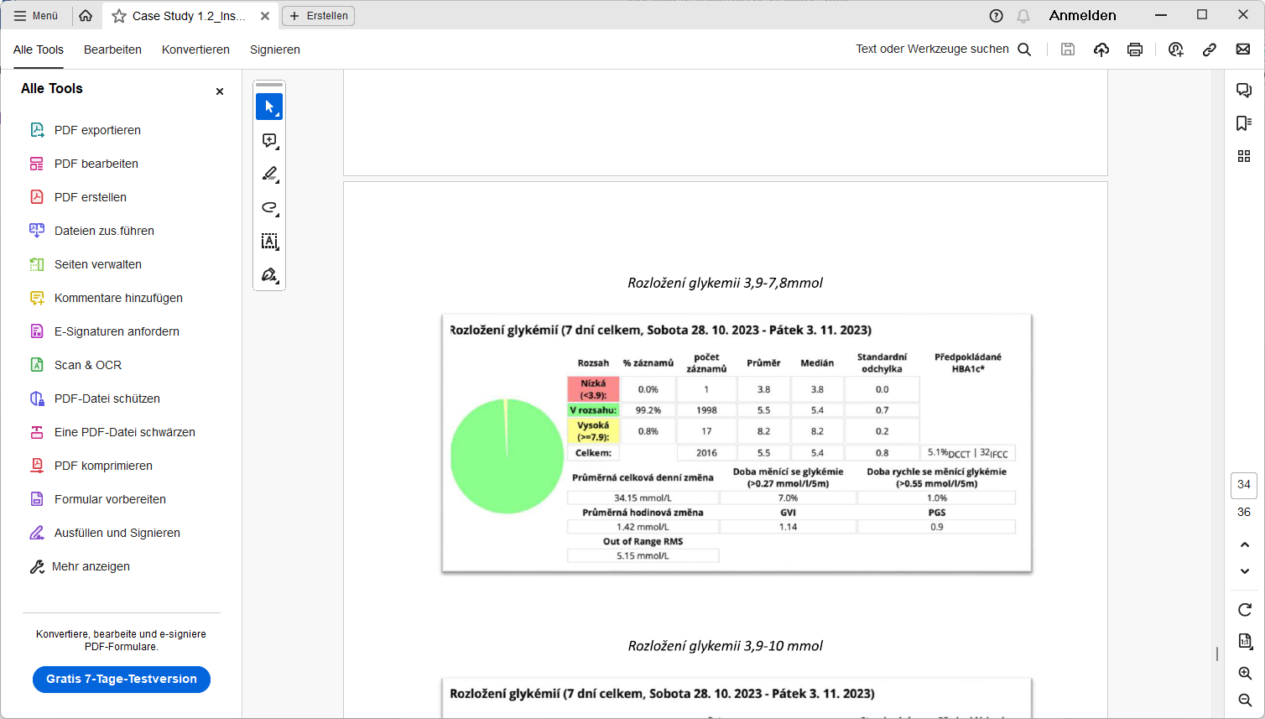 Lyumjev

Fiasp and Apidra had about 10 times as many bg values in the elevated range, above 7.9 mmol/L (142 mg/dl).

It is worth noting here again, that the researched range of meals went up to 300 g carb content (which is a „stress test“, way above my usual range). Loopers on a low carb diet might see FCL viable maybe even using Humalog (ref D. Burren - ?check? )

Besides the performance data reported above, for me this translates also in very important ways into peace of mind and quality of life as a T1D .

FCL with Lyumjev allows me to not watch myself and my diabetes but to trust the system 99.9% of the time.

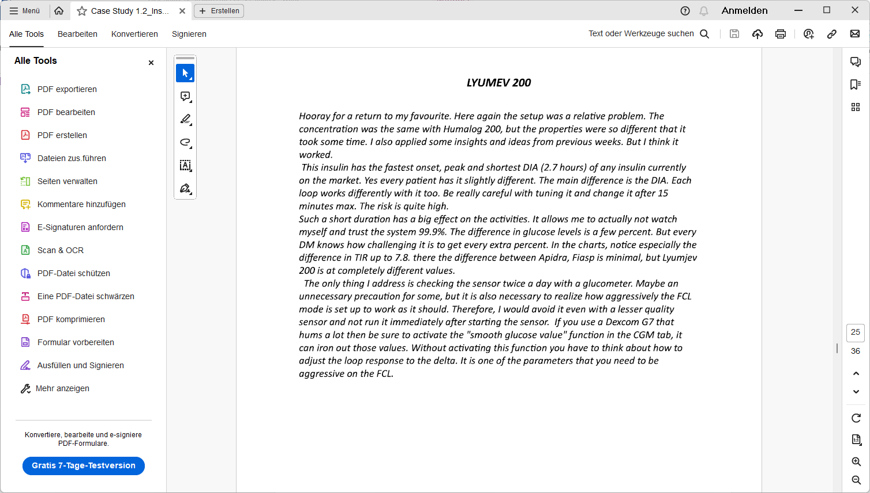

Disclaimer: This is a report on testing weeks done by an experienced FCL user (FCL with AAPS or iAPS since nearly 3 years). Prior to each testing week, up to 10 days were spent to fine tune settings for the insulin in use. Effects from sickness, strenuous exercise etc. were excluded. Attention to technical system function (CGM performance, bluetooth stability, timely cannula changes to limit occlusion) was high in these testing weeks, too.